**RESTful Web Services with Spring Boot**

**2. Step 01 - Initializing a RESTful Services Project with Spring Boot**

Dependency added: Web, JPA, DevTools, H2

4. Step 02 - Understanding the RESTful Services we would create in this course

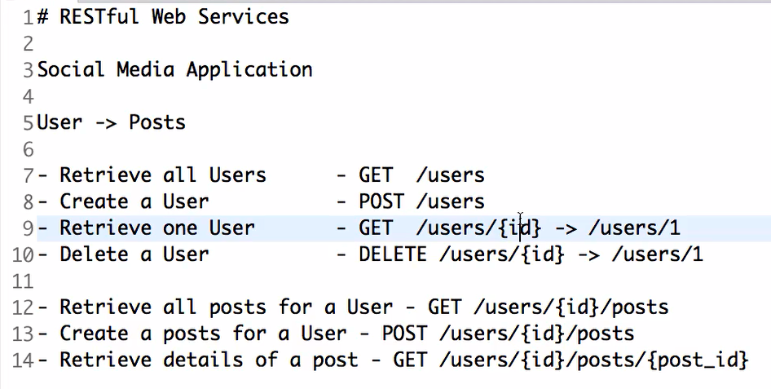

5. Step 03 - Creating a Hello World Service

// To tell spring boot that this will be listening to the rest requests

@RestController

**public** **class** HelloWorldController {

// @GetMapping(path = "/hello-world")

@RequestMapping(method = RequestMethod.***GET***, path = "/hello-world")

**public** String helloWorld() {

**return** "Hello World";

}

}

----------------------------------------------------------------**Step 04 - Enhancing the Hello World Service to return a Bean**

**HelloWorldBean.java**

**package** com.personal.kunj.springbootrestfulservice;

**public** **class** HelloWorldBean {

**private** String message;

**public** HelloWorldBean(String message) {

**this**.message = message;

}

**public** **void** setMessage(String message) {

**this**.message = message;

}

**public** String getMessage() {

**return** message;

}

@Override

**public** String toString() {

**return** "HelloWorldBean [message=" + message + "]";

}

}

Note: // getMessage() is required otherwise we will get the below error.

{

"timestamp": "2018-08-25T09:25:23.693+0000",

"status": 500,

"error": "Internal Server Error",

"message": "No converter found for return value of type: class com.personal.kunj.springbootrestfulservice.HelloWorldBean",

"path": "/hello-world-bean"

}

**HelloWorldController.java**

**package** com.personal.kunj.springbootrestfulservice;

**import** org.springframework.web.bind.annotation.RequestMapping;

**import** org.springframework.web.bind.annotation.RequestMethod;

**import** org.springframework.web.bind.annotation.RestController;

@RestController

**public** **class** HelloWorldController {

// @GetMapping(path = "/hello-world")

@RequestMapping(method = RequestMethod.***GET***, path = "/hello-world")

**public** String helloWorld() {

**return** "Hello World";

}

@RequestMapping(method = RequestMethod.***GET***, path = "/hello-world-bean")

**public** HelloWorldBean helloWorldBean() {

**return** **new** HelloWorldBean("Hello World Bean");

}

}

----------------------------------------------------------------

**Step 05 - Quick Review of Spring Boot Auto Configuration and Dispatcher Servlet**

spring-boot-starter-web has dependency on spring-mvc framework therefore we get org.springframework.web.servlet.DispatcherServlet class in our classpath.

Object to JSON conversion is being done by Spring boot.

DispatcherServlet is handling all the requests. Anything after root [localhost:8080/…]

----------------------------------------------------------------

**Step 06 - Enhancing the Hello World Service with a Path Variable**

@GetMapping(path = "/hello-world/path-var/{name}")

**public** HelloWorldBean helloWorldWithPath(@PathVariable("name") String myName) {

**return** **new** HelloWorldBean(String.*format*("Hello World, %s", myName));

}

----------------------------------------------------------------

**9. Step 07 - Creating User Bean and User Service**

**User.java**

**package** com.personal.kunj.springbootrestfulservice.user;

**import** java.util.Date;

**public** **class** User {

**private** Integer id;

**private** String name;

**private** Date birthDate;

**public** User(Integer id, String name, Date birthDate) {

**super**();

**this**.id = id;

**this**.name = name;

**this**.birthDate = birthDate;

}

**public** Integer getId() {

**return** id;

}

**public** **void** setId(Integer id) {

**this**.id = id;

}

**public** String getName() {

**return** name;

}

**public** **void** setName(String name) {

**this**.name = name;

}

**public** Date getBirthDate() {

**return** birthDate;

}

**public** **void** setBirthDate(Date birthDate) {

**this**.birthDate = birthDate;

}

@Override

**public** String toString() {

**return** String.*format*("User [id=%s, name=%s, birthDate=%s]", id, name, birthDate);

}

}

**UserDaoService.java**

**package** com.personal.kunj.springbootrestfulservice.user;

**import** java.util.ArrayList;

**import** java.util.Date;

**import** java.util.List;

**import** org.springframework.stereotype.Component;

@Component

**public** **class** UserDaoService {

**private** **static** List<User> *users* = **new** ArrayList<>();

**private** **static** **int** *usersCount* = 3;

**static** {

*users*.add(**new** User(1, "Adam", **new** Date()));

*users*.add(**new** User(2, "Eve", **new** Date()));

*users*.add(**new** User(3, "Jack", **new** Date()));

}

**public** List<User> findAll() {

**return** *users*;

}

**public** User save(User user) {

**if** (user.getId() == **null**) {

user.setId(++*usersCount*);

}

*users*.add(user);

**return** user;

}

**public** User findOne(**int** id) {

**for** (User user : *users*) {

**if** (user.getId() == id) {

**return** user;

}

}

**return** **null**;

}

}

**UserResource.java**

**package** com.personal.kunj.springbootrestfulservice.user;

**import** java.util.List;

**import** org.springframework.beans.factory.annotation.Autowired;

**import** org.springframework.web.bind.annotation.GetMapping;

**import** org.springframework.web.bind.annotation.PathVariable;

**import** org.springframework.web.bind.annotation.RestController;

@RestController

**public** **class** UserResource {

@Autowired

**private** UserDaoService service;

@GetMapping("/users")

**public** List<User> retrieveAllUsers() {

**return** service.findAll();

}

@GetMapping("/users/{id}")

**public** User retrieveUser(@PathVariable **int** id) {

**return** service.findOne(id);

}

}

**---------------------------------------------------------------------------------------------------------------------**  **Step 09 - Implementing POST Method to create User Resource**

**User.java**

**package** com.personal.kunj.springbootrestfulservice.user;

**import** java.util.Date;

**public** **class** User {

**private** Integer id;

**private** String name;

**private** Date birthDate;

// Must have for REST to convert json data to a java object

**protected** User() {

}

**public** User(Integer id, String name, Date birthDate) {

**super**();

**this**.id = id;

**this**.name = name;

**this**.birthDate = birthDate;

}

**public** Integer getId() {

**return** id;

}

**public** **void** setId(Integer id) {

**this**.id = id;

}

**public** String getName() {

**return** name;

}

**public** **void** setName(String name) {

**this**.name = name;

}

**public** Date getBirthDate() {

**return** birthDate;

}

**public** **void** setBirthDate(Date birthDate) {

**this**.birthDate = birthDate;

}

@Override

**public** String toString() {

**return** String.*format*("User [id=%s, name=%s, birthDate=%s]", id, name, birthDate);

}

}

**UserResource.java**

**package** com.personal.kunj.springbootrestfulservice.user;

**import** java.util.List;

**import** org.springframework.beans.factory.annotation.Autowired;

**import** org.springframework.web.bind.annotation.GetMapping;

**import** org.springframework.web.bind.annotation.PathVariable;

**import** org.springframework.web.bind.annotation.PostMapping;

**import** org.springframework.web.bind.annotation.RequestBody;

**import** org.springframework.web.bind.annotation.RestController;

@RestController

**public** **class** UserResource {

@Autowired

**private** UserDaoService service;

@GetMapping("/users")

**public** List<User> retrieveAllUsers() {

**return** service.findAll();

}

@GetMapping("/users/{id}")

**public** User retrieveUser(@PathVariable **int** id) {

**return** service.findOne(id);

}

// Input --> Details of the new user

// output --> CREATED (status) and URI of the created resource

@PostMapping(path = "/users")

**public** **void** createUser(@RequestBody User user) {

User newUser = service.save(user);

}

}

---------------------------------------------------------------------------------------------------------------------

**Step 10 - Enhancing POST Method to return correct HTTP Status Code and Location**

**UserResource.java**

**package** com.personal.kunj.springbootrestfulservice.user;

**import** java.net.URI;

**import** java.util.List;

**import** org.springframework.beans.factory.annotation.Autowired;

**import** org.springframework.http.ResponseEntity;

**import** org.springframework.web.bind.annotation.GetMapping;

**import** org.springframework.web.bind.annotation.PathVariable;

**import** org.springframework.web.bind.annotation.PostMapping;

**import** org.springframework.web.bind.annotation.RequestBody;

**import** org.springframework.web.bind.annotation.RestController;

**import** org.springframework.web.servlet.support.ServletUriComponentsBuilder;

@RestController

**public** **class** UserResource {

@Autowired

**private** UserDaoService service;

@GetMapping("/users")

**public** List<User> retrieveAllUsers() {

**return** service.findAll();

}

@GetMapping("/users/{id}")

**public** User retrieveUser(@PathVariable **int** id) {

**return** service.findOne(id);

}

// Input --> Details of the new user

// output --> CREATED (status) and URI of the created resource (Location header

// will have the uri of the new resource)

@PostMapping(path = "/users")

**public** ResponseEntity<Object> createUser(@RequestBody User user) {

User newUser = service.save(user);

URI location = ServletUriComponentsBuilder.*fromCurrentRequest*().path("/{id}").buildAndExpand(newUser.getId())

.toUri();

**return** ResponseEntity.*created*(location).build();

}

}

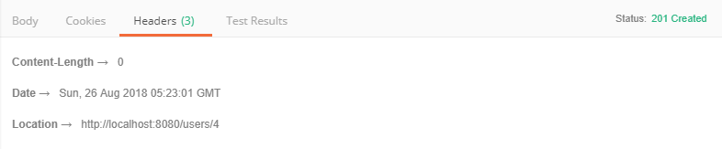

---------------------------------------------------------------------------------------------------------------------

**Step 11 - Implementing Exception Handling - 404 Resource Not Found**

**UserResource.java**

@GetMapping("/users/{id}")

**public** User retrieveUser(@PathVariable **int** id) {

User user = service.findOne(id);

**if** (user == **null**) {

**throw** **new** UserNotFoundException("id-" + id);

}

**return** user;

}

**UserNotFoundException.java**

**package** com.personal.kunj.springbootrestfulservice.user;

**import** org.springframework.http.HttpStatus;

**import** org.springframework.web.bind.annotation.ResponseStatus;

@ResponseStatus(HttpStatus.***NOT_FOUND***)

**public** **class** UserNotFoundException **extends** RuntimeException {

**private** **static** **final** **long** ***serialVersionUID*** = 1L;

**public** UserNotFoundException(String message) {

**super**(message);

}

}

**-------------------------------------------------------------------------------------------------------------------**

**Step 12 - Implementing Generic Exception Handling for all Resources**

**ResponseEntityExceptionHandler 🡪** A convenient base class for [@ControllerAdvice](https://docs.spring.io/spring-framework/docs/current/javadoc-api/org/springframework/web/bind/annotation/ControllerAdvice.html) classes that wish to provide centralized exception handling across all @RequestMapping methods through @ExceptionHandler methods.

**ExceptionResponse.java**

**package** com.personal.kunj.springbootrestfulservice.exception;

**import** java.util.Date;

**public** **class** ExceptionResponse {

**private** Date timestamp;

**private** String message;

**private** String details;

**public** ExceptionResponse(Date timestamp, String message, String details) {

**super**();

**this**.timestamp = timestamp;

**this**.message = message;

**this**.details = details;

}

**public** Date getTimestamp() {

**return** timestamp;

}

**public** String getMessage() {

**return** message;

}

**public** String getDetails() {

**return** details;

}

}

**CustomResponseEntityExceptionHandler.java**

**package** com.personal.kunj.springbootrestfulservice.exception;

**import** java.util.Date;

**import** org.springframework.http.HttpStatus;

**import** org.springframework.http.ResponseEntity;

**import** org.springframework.web.bind.annotation.ControllerAdvice;

**import** org.springframework.web.bind.annotation.ExceptionHandler;

**import** org.springframework.web.bind.annotation.RestController;

**import** org.springframework.web.context.request.WebRequest;

**import** org.springframework.web.servlet.mvc.method.annotation.ResponseEntityExceptionHandler;

**import** com.personal.kunj.springbootrestfulservice.user.UserNotFoundException;

// To share this exception across controllers

@ControllerAdvice

// As it is providing response

@RestController

**public** **class** CustomResponseEntityExceptionHandler **extends** ResponseEntityExceptionHandler {

@ExceptionHandler(Exception.**class**) // To handle all the exceptions

**public** **final** ResponseEntity<Object> handleAllExceptions(Exception ex, WebRequest request) {

// We want to return our exception response back

ExceptionResponse exceptionResponse = **new** ExceptionResponse(**new** Date(), ex.getMessage(),

request.getDescription(**false**));

**return** **new** ResponseEntity<Object>(exceptionResponse, HttpStatus.***INTERNAL_SERVER_ERROR***);

}

@ExceptionHandler(UserNotFoundException.**class**) // To handle all the exceptions

**public** **final** ResponseEntity<Object> handleUserNotFoundException(UserNotFoundException ex, WebRequest request) {

// We want to return our exception response back

ExceptionResponse exceptionResponse = **new** ExceptionResponse(**new** Date(), ex.getMessage(),

request.getDescription(**false**));

**return** **new** ResponseEntity<Object>(exceptionResponse, HttpStatus.***NOT_FOUND***);

}

}

--------------------------------------------------------------------------------------------------------------------

**Step 13 - Exercise User Post Resource and Exception Handling**

Bol Bachchan

---------------------------------------------------------------------------------------------------------------------

**Step 14 - Implementing DELETE Method to delete a User Resource**

**UserResource.java**

@DeleteMapping("/users/{id}")

**public** **void** deleteUser(@PathVariable **int** id) {

User user = service.deleteById(id);

**if** (user == **null**)

**throw** **new** UserNotFoundException("id-" + id);

}

**UserDaoService.java**

**public** User deleteById(**int** id) {

Iterator<User> iterator = *users*.iterator();

**while** (iterator.hasNext()) {

User user = iterator.next();

**if** (user.getId() == id) {

iterator.remove();

**return** user;

}

}

**return** **null**;

}

----------------------------------------------------------------

Step 15 - Implementing Validations for RESTful Services

**CustomResponseEntityExceptionHandler.java**

@Override

**protected** ResponseEntity<Object> handleMethodArgumentNotValid(MethodArgumentNotValidException ex,

HttpHeaders headers, HttpStatus status, WebRequest request) {

ExceptionResponse exceptionResponse = **new** ExceptionResponse(**new** Date(), "Validation Failed",

ex.getBindingResult().toString());

**return** **new** ResponseEntity<Object>(exceptionResponse, HttpStatus.***BAD_REQUEST***);

}

**User.java**

**private** Integer id;

@Size(min = 2, message = "Name should have at least 2 characters")

**private** String name;

@Past

**private** Date birthDate;

**UserResource.java**

@PostMapping(path = "/users")

**public** ResponseEntity<Object> createUser(@Valid @RequestBody User user) {

----------------------------------------------------------------

**Step 16 - Implementing HATEOAS for RESTful Services**

**pom.xml**

<dependency>

<groupId>org.springframework.boot</groupId>

<artifactId>spring-boot-starter-hateoas</artifactId>

</dependency>

**UserResource.java**

@GetMapping("/users/{id}")

**public** Resource<User> retrieveUser(@PathVariable **int** id) {

User user = service.findOne(id);

**if** (user == **null**) {

**throw** **new** UserNotFoundException("id-" + id);

}

// HATEOAS

// Creating resource around the user

Resource<User> resource = **new** Resource<User>(user);

/*

* Now add links to the resource. But before this, get the links for retrieveAllUsers(). We are getting the links for retrieveAllUsers() bcz we do not want to hard code the path to "/users". ControllerLinkBuilder class helps us in creating links from methods.

*/

ControllerLinkBuilder linkTo = ControllerLinkBuilder.*linkTo*(**this**.getClass(), retrieveAllUsers());

resource.add(linkTo.withRel("all-users"));

**return** resource;

}

O/P:

**{**

**"id": 1,**

**"name": "Adam",**

**"birthDate": "2018-08-26T11:54:35.334+0000",**

**"_links": {**

**"all-users": {**

**"href": "http://localhost:8080"**

**}**

**}**

**}**

---------------------------------------------------------------------------------------------------------------------------

**Step 17 - Overview of Advanced RESTful Service Features**

**---------------------------------------------------------------**

**Step 18 - Internationalization for RESTful Services**

Internationalization(i18n) 🡪 Customizing your services for your different people around the world

Internationalization :

**## Configuration to be done:**

* LocaleResolver
* 🡪 Default Locale – locale.US (if a user does not ask for the customization, locale.US will be shown as the default locale)
* ResourceBundleMessageSource (We will store here the List of properties which will be internationalized). ResourceBundleMessageSource is a spring concept for handling properties.

**## Usage**

* Autowire MessageSource
* @RequestHeader(value=”Accept-Language”, required=false) Locale locale
* messageSource.getMessage(“helloWorld.message”, null,locale)

**-------------**

**Messages.properties**

good.morning.message=Good Morning

**Messages_fr.properties**

good.morning.message=Bonjour

**HelloWorldController.java**

@RequestMapping(method = RequestMethod.***GET***, path = "/hello-world-internationalized")

**public** String helloWorldnternationalized(@RequestHeader(name = "Accept-Language", required = **false**) Locale locale) {

**return** messageSource.getMessage("good.morning.message", **null**, locale);

}

**SpringbootRestfulServiceApplication.java**

package com.personal.kunj.springbootrestfulservice;

import java.util.Locale;

import org.springframework.boot.SpringApplication;

import org.springframework.boot.autoconfigure.SpringBootApplication;

import org.springframework.context.annotation.Bean;

import org.springframework.context.support.ResourceBundleMessageSource;

import org.springframework.web.servlet.LocaleResolver;

import org.springframework.web.servlet.i18n.AcceptHeaderLocaleResolver;

@SpringBootApplication

public class SpringbootRestfulServiceApplication {

public static void main(String[] args) {

SpringApplication.run(SpringbootRestfulServiceApplication.class, args);

}

@Bean

public LocaleResolver localeResolver() {

SessionLocaleResolver localeResolver = new SessionLocaleResolver();

localeResolver.setDefaultLocale(Locale.US);

return localeResolver;

}

@Bean

public ResourceBundleMessageSource messageSource() {

ResourceBundleMessageSource resourceBundleMessageSource = new ResourceBundleMessageSource();

resourceBundleMessageSource.setBasename("messages");

return resourceBundleMessageSource;

}

}

------------------------------------------------------------------------------------------------------------------------------

**Step 18 Part 2 - Internationalization for RESTful Services**

An Alternative to the above approach:

**Application.properties**

spring.messages.basename=messages

**SpringbootRestfulServiceApplication.java**

package com.personal.kunj.springbootrestfulservice;

import java.util.Locale;

import org.springframework.boot.SpringApplication;

import org.springframework.boot.autoconfigure.SpringBootApplication;

import org.springframework.context.annotation.Bean;

import org.springframework.web.servlet.LocaleResolver;

import org.springframework.web.servlet.i18n.AcceptHeaderLocaleResolver;

@SpringBootApplication

public class SpringbootRestfulServiceApplication {

public static void main(String[] args) {

SpringApplication.run(SpringbootRestfulServiceApplication.class, args);

}

@Bean

public LocaleResolver localeResolver() {

// After using AcceptHeaderLocaleResolver, we will not need to configure locale

// as request parameter/header in every controller method

AcceptHeaderLocaleResolver localeResolver = new AcceptHeaderLocaleResolver();

localeResolver.setDefaultLocale(Locale.US);

return localeResolver;

}

/*

* You can replace this code with property "spring.messages.basename=messages"

* in application.properties

*/

/*

* @Bean public ResourceBundleMessageSource messageSource() {

* ResourceBundleMessageSource resourceBundleMessageSource = new

* ResourceBundleMessageSource();

* resourceBundleMessageSource.setBasename("messages"); return

* resourceBundleMessageSource; }

*/

}

**HelloWorldController.java**

@RequestMapping(method = RequestMethod.***GET***, path = "/hello-world-internationalized")

**public** String helloWorldnternationalized() {

**return** messageSource.getMessage("good.morning.message", **null**, LocaleContextHolder.*getLocale*());

}

-------------------------------------------------------------------------------------------------------------------------------

**Step 19 - Content Negotiation - Implementing Support for XML**

<dependency> <groupId>com.fasterxml.jackson.dataformat</groupId>

<artifactId>jackson-dataformat-xml</artifactId>

</dependency>

----------------------------------------------------------------

**Step 20 - Configuring Auto Generation of Swagger Documentation**

Swagger is documentation format for rest web services.

Add dependencies:

<dependency>

<groupId>io.springfox</groupId>

<artifactId>springfox-swagger2</artifactId>

<version>2.7.0</version>

</dependency>

<dependency>

<groupId>io.springfox</groupId>

<artifactId>springfox-swagger2</artifactId>

<version>2.7.0</version>

</dependency>

Configure Swagger:

**SwaggerConfig.java**

**package** com.personal.kunj.springbootrestfulservice;

**import** org.springframework.context.annotation.Bean;

**import** org.springframework.context.annotation.Configuration;

**import** springfox.documentation.spi.DocumentationType;

**import** springfox.documentation.spring.web.plugins.Docket;

**import** springfox.documentation.swagger2.annotations.EnableSwagger2;

// configuration

@Configuration

// Enable Swagger

@EnableSwagger2

**public** **class** SwaggerConfig {

// Bean - Docket

@Bean

**public** Docket api() {

**return** **new** Docket(DocumentationType.***SWAGGER_2***);

/*

* return new

* Docket(DocumentationType.SWAGGER_2).select().apis(RequestHandlerSelectors.any

* ()) .paths(PathSelectors.any()).build();

*/

}

}

<http://localhost:8080/v2/api-docs> 🡪 documentation URL

<http://localhost:8080/swagger-ui.html>

-------------------------------------------------------------------------------------------------------------------------------

**Step 21 - Introduction to Swagger Documentation Format**

------------------------------------------------------------------------------------------------------------------------------

**Step 22 - Enhancing Swagger Documentation with Custom Annotations**

**SwaggerConfig.java**

**package** com.personal.kunj.springbootrestfulservice;

**import** java.util.ArrayList;

**import** java.util.Arrays;

**import** java.util.HashSet;

**import** java.util.Set;

**import** org.springframework.context.annotation.Bean;

**import** org.springframework.context.annotation.Configuration;

**import** springfox.documentation.service.ApiInfo;

**import** springfox.documentation.service.Contact;

**import** springfox.documentation.service.VendorExtension;

**import** springfox.documentation.spi.DocumentationType;

**import** springfox.documentation.spring.web.plugins.Docket;

**import** springfox.documentation.swagger2.annotations.EnableSwagger2;

// configuration

@Configuration

// Enable Swagger

@EnableSwagger2

**public** **class** SwaggerConfig {

**public** **static** **final** Contact ***DEFAULT_CONTACT*** = **new** Contact("Kunj Biahri", "www.kunjbihari.com",

"kunj.bihari@abc.com");

**public** **static** **final** ApiInfo ***DEFAULT_API_INFO*** = **new** ApiInfo("Kunj's API Title", "Kunj's API Description", "1.0",

"urn:tos", ***DEFAULT_CONTACT***, "Apache 2.0", "http://www.apache.org/licenses/LICENSE-2.0",

**new** ArrayList<VendorExtension>());

**private** **static** **final** Set<String> ***DEFAULT_PRODUCES_AND_CONSUMES*** = **new** HashSet<String>(

Arrays.*asList*("application/json", "application/xml"));

// Bean - Docket

@Bean

**public** Docket api() {

**return** **new** Docket(DocumentationType.***SWAGGER_2***).apiInfo(***DEFAULT_API_INFO***).produces(***DEFAULT_PRODUCES_AND_CONSUMES***)

.consumes(***DEFAULT_PRODUCES_AND_CONSUMES***);

/*

* return new

* Docket(DocumentationType.SWAGGER_2).select().apis(RequestHandlerSelectors.any

* ()) .paths(PathSelectors.any()).build();

*/

}

}

**User.java**

package com.personal.kunj.springbootrestfulservice.user;

import java.util.Date;

import javax.validation.constraints.Past;

import javax.validation.constraints.Size;

import io.swagger.annotations.ApiModel;

import io.swagger.annotations.ApiModelProperty;

// Providing more info about the user in swagger documentation

@ApiModel(description = "All details about the user")

public class User {

private Integer id;

@Size(min = 2, message = "Name should have at least 2 characters")

// To show the notes in the swagger documentation

@ApiModelProperty(notes = "Name should have at least 2 characters")

private String name;

@Past

@ApiModelProperty(notes = "Bithdate should be in the past")

private Date birthDate;

// Must have for REST to convert json data to a java object

protected User() {

}

public User(Integer id, String name, Date birthDate) {

super();

this.id = id;

this.name = name;

this.birthDate = birthDate;

}

public Integer getId() {

return id;

}

public void setId(Integer id) {

this.id = id;

}

public String getName() {

return name;

}

public void setName(String name) {

this.name = name;

}

public Date getBirthDate() {

return birthDate;

}

public void setBirthDate(Date birthDate) {

this.birthDate = birthDate;

}

@Override

public String toString() {

return String.format("User [id=%s, name=%s, birthDate=%s]", id, name, birthDate);

}

}

-------------------------------------------------------------------------------------------------------------------------------

**Step 23 - Monitoring APIs with Spring Boot Actuator**

**pom.xml**

<dependency>

<groupId>org.springframework.boot</groupId>

<artifactId>spring-boot-starter-actuator</artifactId>

</dependency>

<dependency>

<groupId>org.springframework.data</groupId>

<artifactId>spring-data-rest-hal-browser</artifactId>

</dependency>

**Application.properties**

## Enabling exposure over HTTP of all the management end points (actuator specific config)

management.endpoints.web.exposure.include=*

Actuator URL: http://localhost:8080/actuator

HAL Browser URl: localhost:8080/browser/index.html

---------------------------------------------------------------

**Step 24 - Implementing Static Filtering for RESTful Service**

If we want to ignore fields based on scenarios, we have to go foe dynamic filtering.

**SomeBean.java**

**package** com.personal.kunj.springbootrestfulservice.filtering;

**import** com.fasterxml.jackson.annotation.JsonIgnore;

**import** com.fasterxml.jackson.annotation.JsonIgnoreProperties;

// Other way to ignore fields in the response

@JsonIgnoreProperties(value = { "field1" })

**public** **class** SomeBean {

**private** String field1;

**private** String field2;

// Let's say this field is secure and we do not want to pass this field in the

// response

@JsonIgnore

**private** String field3;

**public** SomeBean(String field1, String field2, String field3) {

**super**();

**this**.field1 = field1;

**this**.field2 = field2;

**this**.field3 = field3;

}

**public** String getField1() {

**return** field1;

}

**public** **void** setField1(String field1) {

**this**.field1 = field1;

}

**public** String getField2() {

**return** field2;

}

**public** **void** setField2(String field2) {

**this**.field2 = field2;

}

**public** String getField3() {

**return** field3;

}

**public** **void** setField3(String field3) {

**this**.field3 = field3;

}

}

-------------------------------------------------------------------------------------------------------------------------------

**Step 25 - Implementing Dynamic Filtering for RESTful Service**

In dynamic filtering we have to start the filtering right there where we are retrieving the values (Unlike static filtering where we are doing the filtering at the bean).

**SomeBean.java**

@JsonFilter("SomeBeanFilter")

**public** **class** SomeBean {

// fields and methods

}

**FilteringController.java**

**package** com.personal.kunj.springbootrestfulservice.filtering;

**import** org.springframework.http.converter.json.MappingJacksonValue;

**import** org.springframework.web.bind.annotation.GetMapping;

**import** org.springframework.web.bind.annotation.RestController;

**import** com.fasterxml.jackson.databind.ser.FilterProvider;

**import** com.fasterxml.jackson.databind.ser.impl.SimpleBeanPropertyFilter;

**import** com.fasterxml.jackson.databind.ser.impl.SimpleFilterProvider;

@RestController

**public** **class** FilteringController {

// We only want to send field1,field2 in the response

@GetMapping("/filtering")

**public** MappingJacksonValue retrieveSomeBean() {

SomeBean someBean = **new** SomeBean("value1", "value2", "value3");

// Filter out all the fields in the response except field1 and field2

SimpleBeanPropertyFilter filter = SimpleBeanPropertyFilter.*filterOutAllExcept*("field1", "field2");

FilterProvider filters = **new** SimpleFilterProvider().addFilter("SomeBeanFilter", filter);

MappingJacksonValue mapping = **new** MappingJacksonValue(someBean);

mapping.setFilters(filters);

**return** mapping;

}

}

------------------------------------------------------------------------------------------------------------------------------

**Step 26 - Versioning RESTful Services - Basic Approach with URIs**

**Create** a package versioning.

Create 2 classes PersonV1 and PersonV2.

PersonV1 🡪 Wants a name to be returned as a String (one name).

PersonV2 🡪 Wants a name to be displayed as first and last name.

How do we solve this problem? For the same API we need to have 2 versions, one giving the combined name back and other giving the name as first and last name. How do we create 2 versions of the same service?

**package** com.personal.kunj.springbootrestfulservice.versioning;

**public** **class** PersonV1 {

**private** String name;

**public** PersonV1() {

**super**();

}

**public** PersonV1(String name) {

**super**();

**this**.name = name;

}

**public** String getName() {

**return** name;

}

**public** **void** setName(String name) {

**this**.name = name;

}

}

**package** com.personal.kunj.springbootrestfulservice.versioning;

**public** **class** PersonV2 {

**private** Name name;

**public** PersonV2() {

**super**();

}

**public** PersonV2(Name name) {

**super**();

**this**.name = name;

}

**public** Name getName() {

**return** name;

}

**public** **void** setName(Name name) {

**this**.name = name;

}

}

**package** com.personal.kunj.springbootrestfulservice.versioning;

**public** **class** Name {

**private** String firstName;

**private** String lastName;

**public** Name() {

}

**public** Name(String firstName, String lastName) {

**super**();

**this**.firstName = firstName;

**this**.lastName = lastName;

}

**public** String getFirstName() {

**return** firstName;

}

**public** **void** setFirstName(String firstName) {

**this**.firstName = firstName;

}

**public** String getLastName() {

**return** lastName;

}

**public** **void** setLastName(String lastName) {

**this**.lastName = lastName;

}

}

package com.personal.kunj.springbootrestfulservice.versioning;

import org.springframework.web.bind.annotation.GetMapping;

import org.springframework.web.bind.annotation.RestController;

@RestController

public class PersonVersioningController {

@GetMapping("v1/person")

public PersonV1 personV1() {

return new PersonV1("Bob Charlie");

}

@GetMapping("v2/person")

public PersonV2 personV2() {

return new PersonV2(new Name("Bob", "Charlie"));

}

}

-------------------------------------------------------------------------------------------------------------------------------

30. Step 27 - Versioning RESTful Services - Header and Content Negotiation Approach

1. Doing versioning using a request parameter

@GetMapping(value = "/person/param", params = "version=1")

**public** PersonV1 paramV1() {

**return** **new** PersonV1("Bob Charlie");

}

@GetMapping(value = "/person/param", params = "version=2")

**public** PersonV2 paramV2() {

**return** **new** PersonV2(**new** Name("Bob", "Charlie"));

}

URL: <http://localhost:8080/person/param?version=1>

1. Doing versioning using a request header

@GetMapping(value = "/person/header", headers = "X-API-VERSION=1")

**public** PersonV1 headerV1() {

**return** **new** PersonV1("Bob Charlie");

}

@GetMapping(value = "/person/header", headers = "X-API-VERSION=2")

**public** PersonV2 headerV2() {

**return** **new** PersonV2(**new** Name("Bob", "Charlie"));

}

1. Content negotiation or Accept versioning

@GetMapping(value = "/person/produces", produces = "application/vnd.company.app-v1+json")

public PersonV1 producesV1() {

return new PersonV1("Bob Charlie");

}

@GetMapping(value = "/person/produces", produces = "application/vnd.company.app-v2+json")

public PersonV2 producesV2() {

return new PersonV2(new Name("Bob", "Charlie"));

}

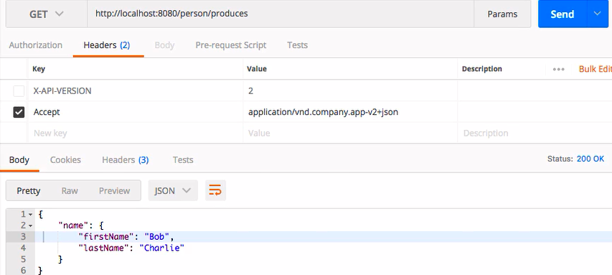

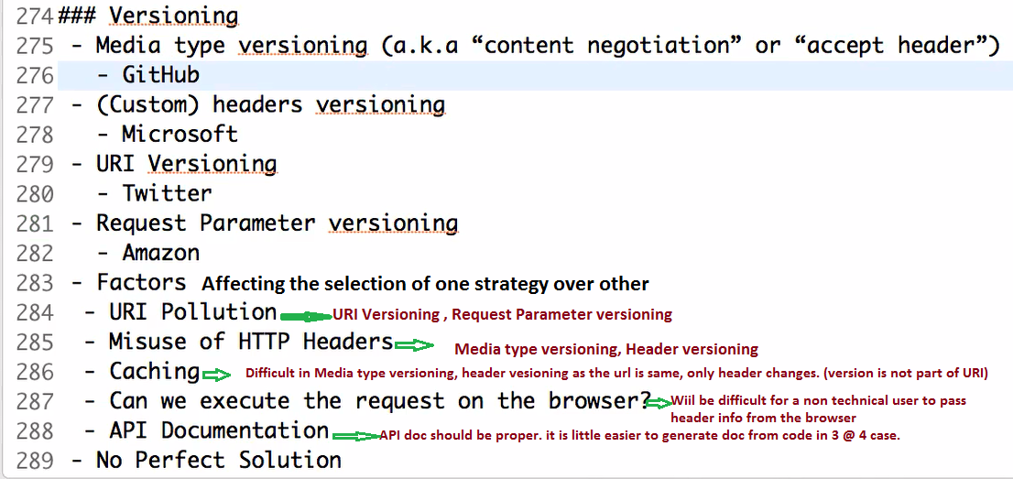

------------------------------------------------------------------------------------------------------------------------------

**Step 28 - Implementing Basic Authentication with Spring Security**

**pom.xml**

<dependency>

<groupId>org.springframework.boot</groupId>

<artifactId>spring-boot-starter-security </artifactId>

</dependency>

Default username : user

Default password : Take from console

**Note:** If you do not like the default credentials, you can configure them as below in application.properties.

spring.security.user.name=username

spring.security.user.password=password

----------------------------------------------------------------

Step 29 - Overview of Connecting RESTful Service to JPA

Step 30 - Creating User Entity and some test data

Step 31 - Updating GET methods on User Resource to use JPA

Step 32 - Updating POST and DELETE methods on User Resource to use JPA

Step 36 - Richardson Maturity Model

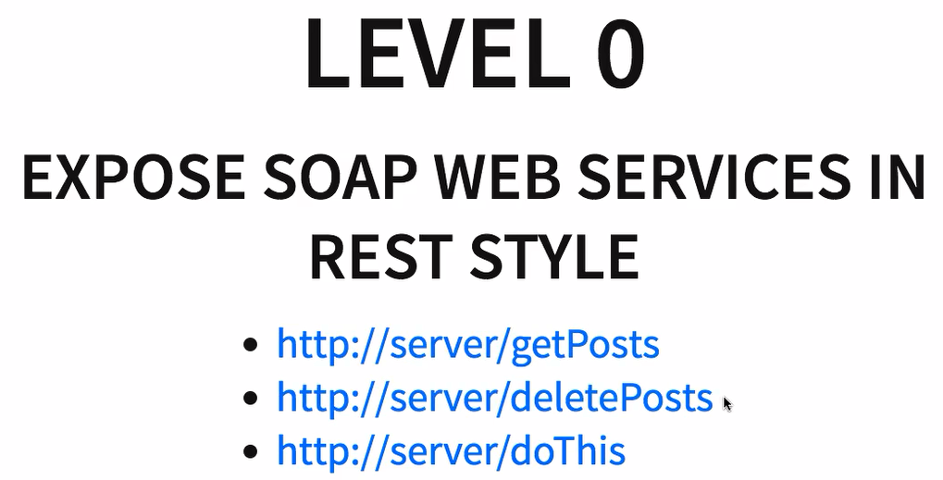

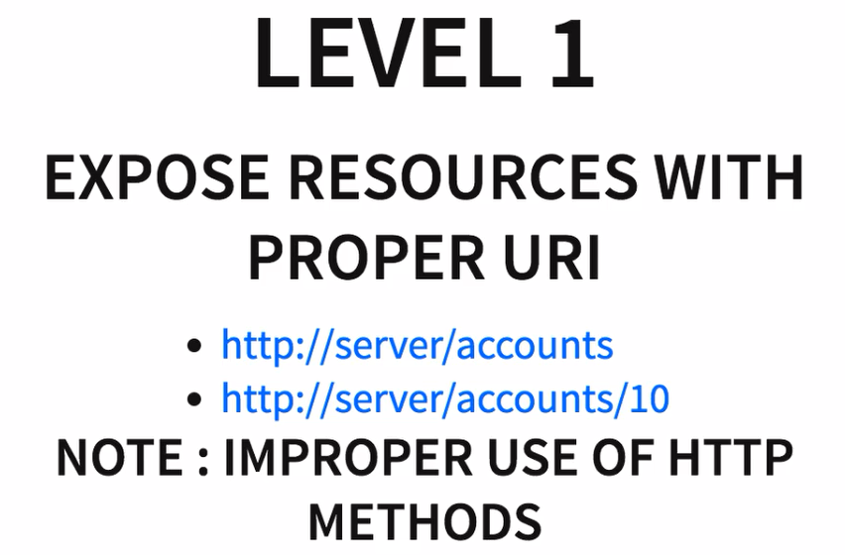



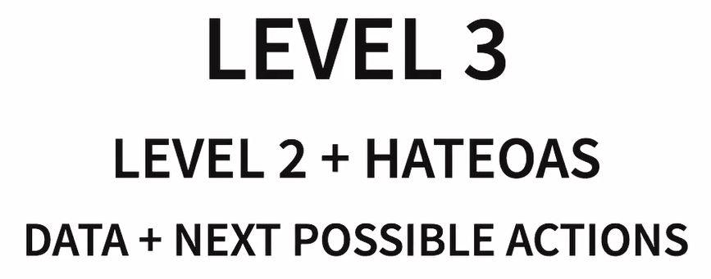

Step 37 - RESTful Web Services - Best Practices

CONSUMER FIRST

GREAT DOCUMENTATION

MAKE BEST USE OF HTTP

MAKE THE BEST USE OF REQUEST METHODS

. GET

.POST

.PUT

.DELETE

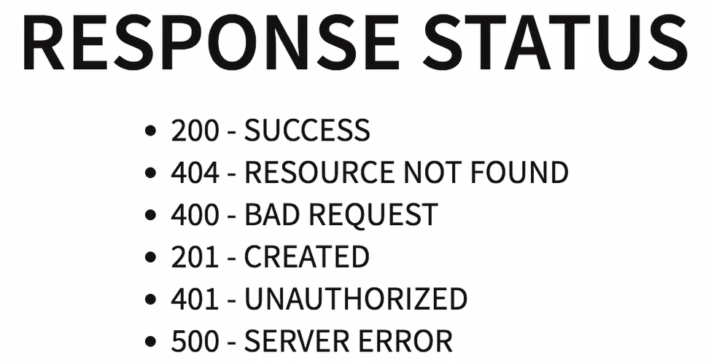

NO SECURE INFO IN THE URI

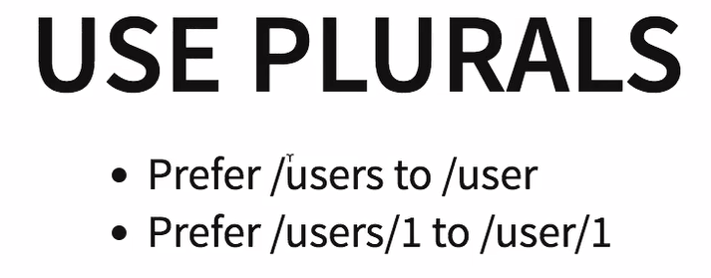



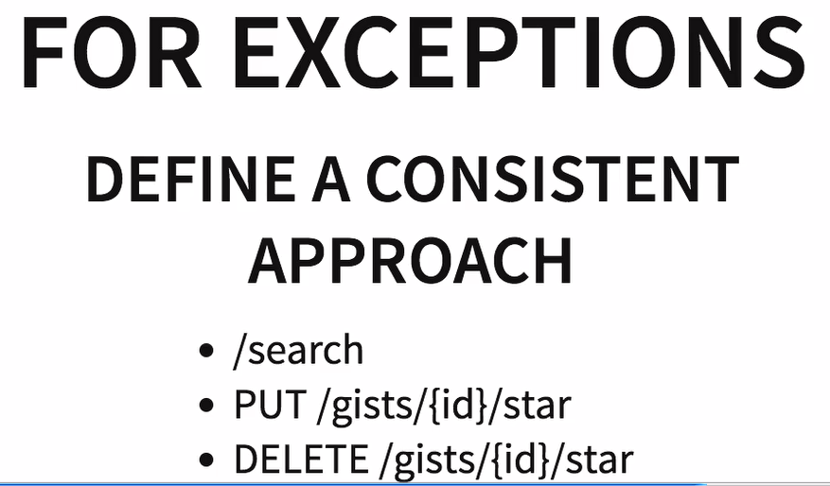

Examples of the above: If there is a search link on the web page. Define a consistent approach.